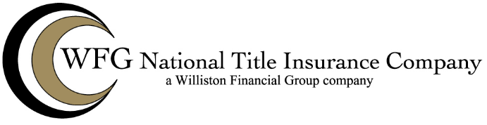

Commercial Lender NM FORM 93

**NM FORM 93: COMMERCIAL LENDER ENDORSEMENT**

**Attached to Policy No. __________   
Issued by**

**WFG NATIONAL TITLE INSURANCE COMPANY**

1. The insurance provided by this endorsement is

a. subject to the Exclusions from Coverage, the Exceptions from Coverage contained in Schedule B,

and the Conditions in the policy, and

b. only effective if the Land is not improved with a one-to-four family residential dwelling.

2. For the purposes of this endorsement only:

a. “Lender Group” means a group of lenders owning portions of the Indebtedness. The composition of the Lender Group may change by the addition or withdrawal of Participants during the term of the Insured Mortgage.

b. “Participant” means a member of the Lender Group, but does not include a non-insure obligor as described in Section 12(c) of the Conditions. A Participant is an Insured under the policy to the extent of its ownership of a portion of the indebtedness, whether it acquires its portion of the Indebtedness on or after Date of Policy.

3. The Company insures against loss or damage sustained by the Insured by reason of:

a. The invalidity or unenforceability of the lien of the Insured Mortgage caused by transfers after the Date of Policy of portions of the Indebtedness by the Participants.

b. Loss of priority of the lien of the Insured Mortgage, which loss of priority is caused by transfers after the Date of Policy of portions of the Indebtedness by the Participants.

4. The Company reserves all rights and defenses as to any Participant that the Company would have had

against any other Insured under the policy unless the Participant acquired its portion of the Indebtedness as

a purchaser for value without Knowledge of the asserted defect, lien, encumbrance, or other matter insured

against by this policy.

WFG 93 NM (9-22-2025)

Modeled on, but not necessarily identical to, ALTA Form 42-06 (adopted 12-02-2013).

Commercial Lender NM FORM 93

This endorsement is issued as part of the policy. Except as it expressly states, it does not (i) modify any of the terms and provisions of the policy, (ii) modify any prior endorsements, (iii) extend the Date of Policy, or (iv) increase the Amount of Insurance. To the extent a provision of the policy or a previous endorsement is inconsistent with an express provision of this endorsement, this endorsement controls. Otherwise, this endorsement is subject to all of the terms and provisions of the policy and of any prior endorsements.

[Witness clause]

[DATE}

WFG NATIONAL TITLE INSURANCE COMPANY

By: _______________________________________ [Authorized Signatory]

WFG NM 93 (9-22-2025)

Modeled on, but not necessarily identical to, ALTA Form 42-06 (adopted 12-02-2013).